**TUGAS INDIVIDU**

**PEMROGRAMAN BERBASIS FRAMEWORK**

**PERTEMUAN 6**

Disusun oleh:

**Rijal Ammar Irsyadul Ibad**

**TI-3B/2041720184**

**D4 TEKNIK INFORMATIKA**

**TEKNOLOGI INFORMASI**

**POLITEKNIK NEGERI MALANG**

**2023**

1. Props Class Component Percobaan 1

Code:

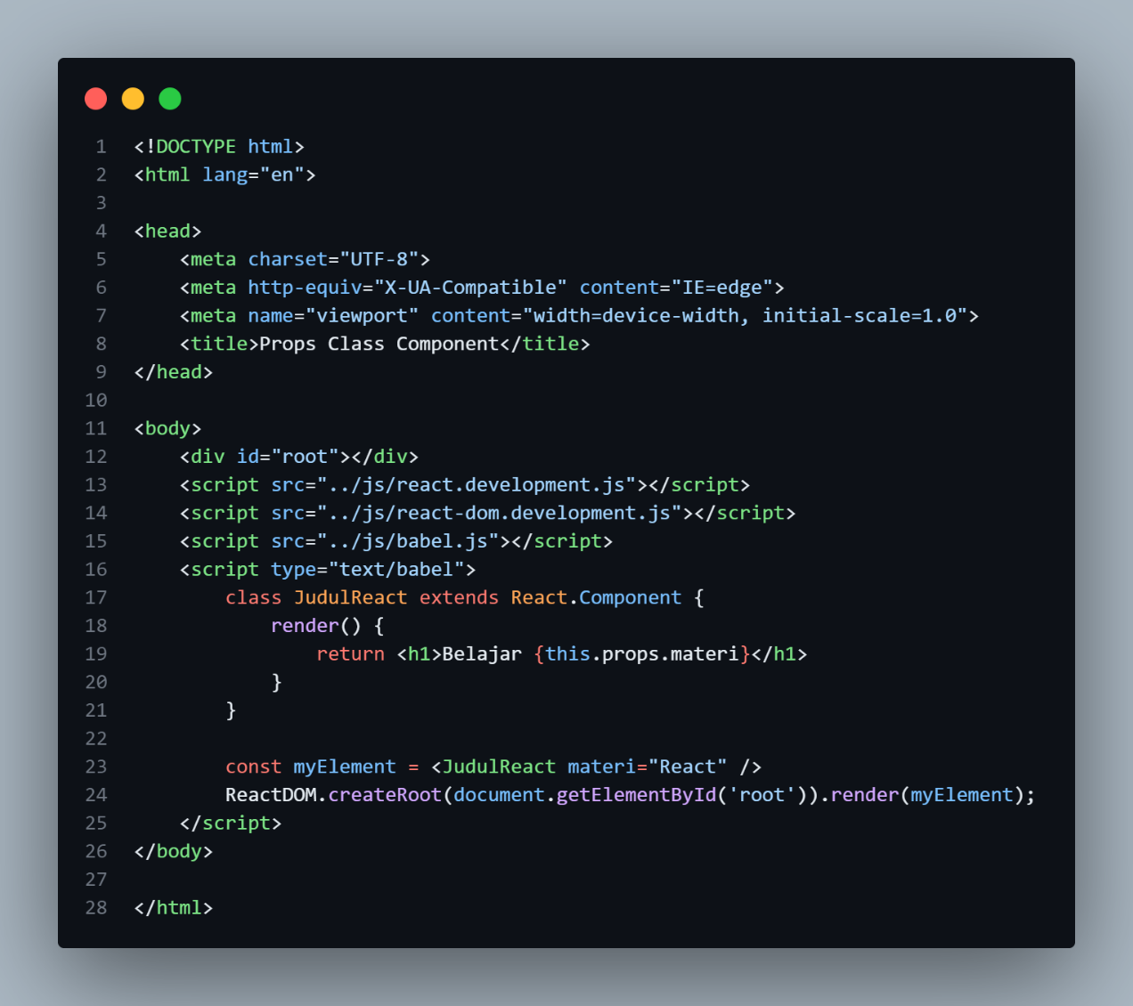

Hasil  
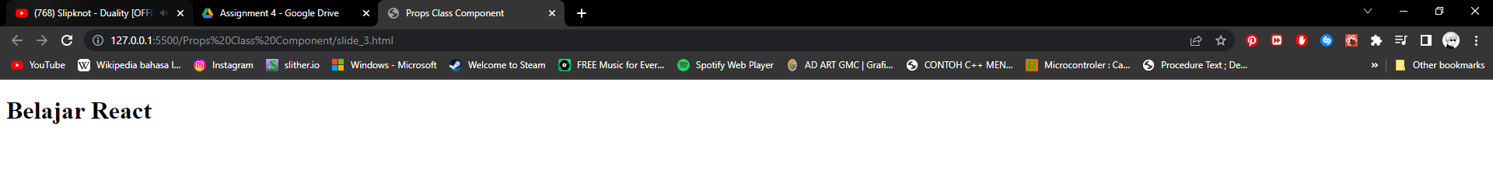

1. Props Class Component Percobaan 2

Code:

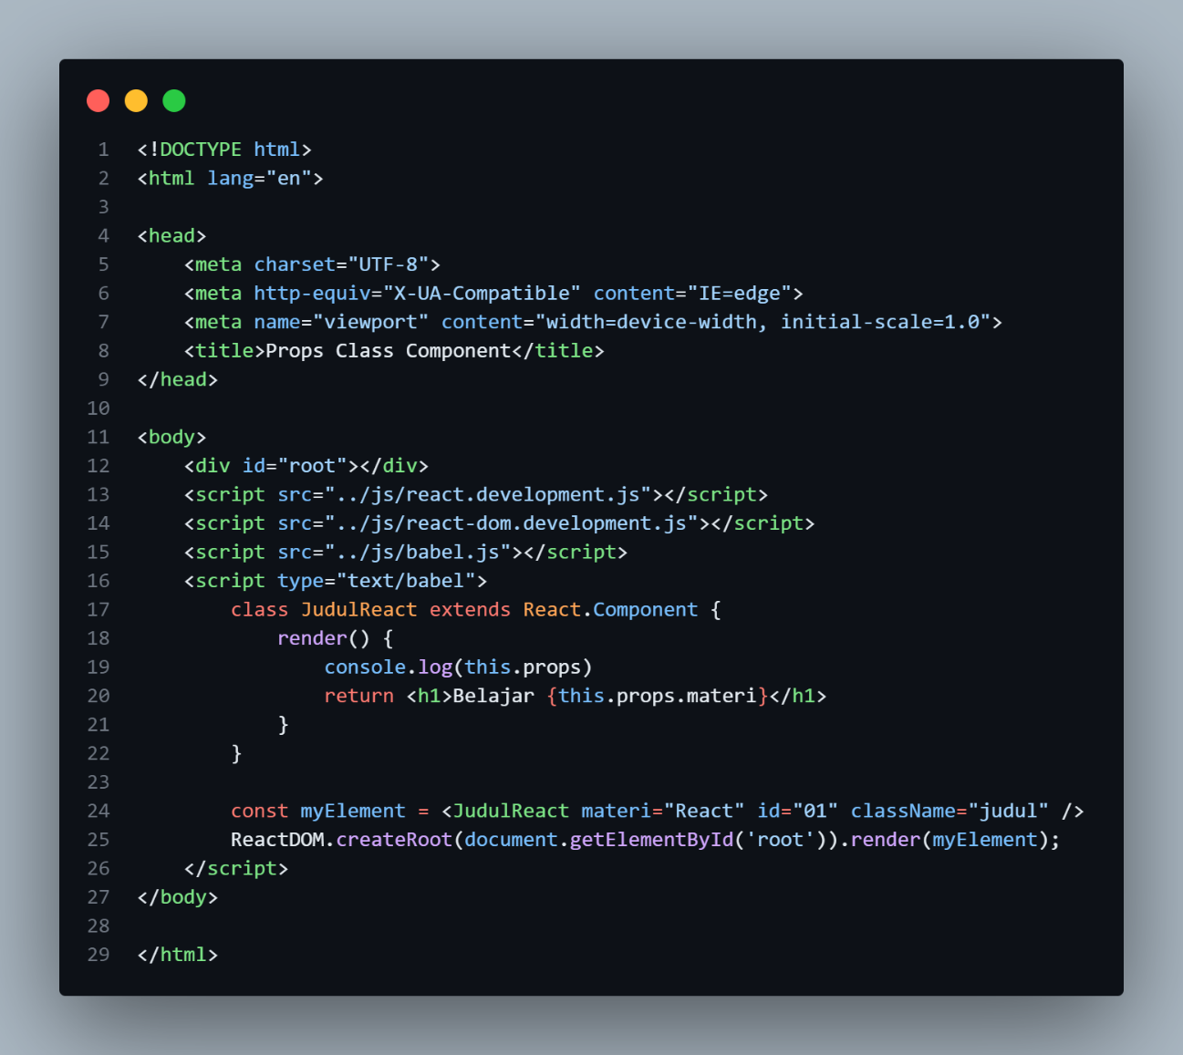

Hasil

1. Props Class Component Percobaan 3

Code:

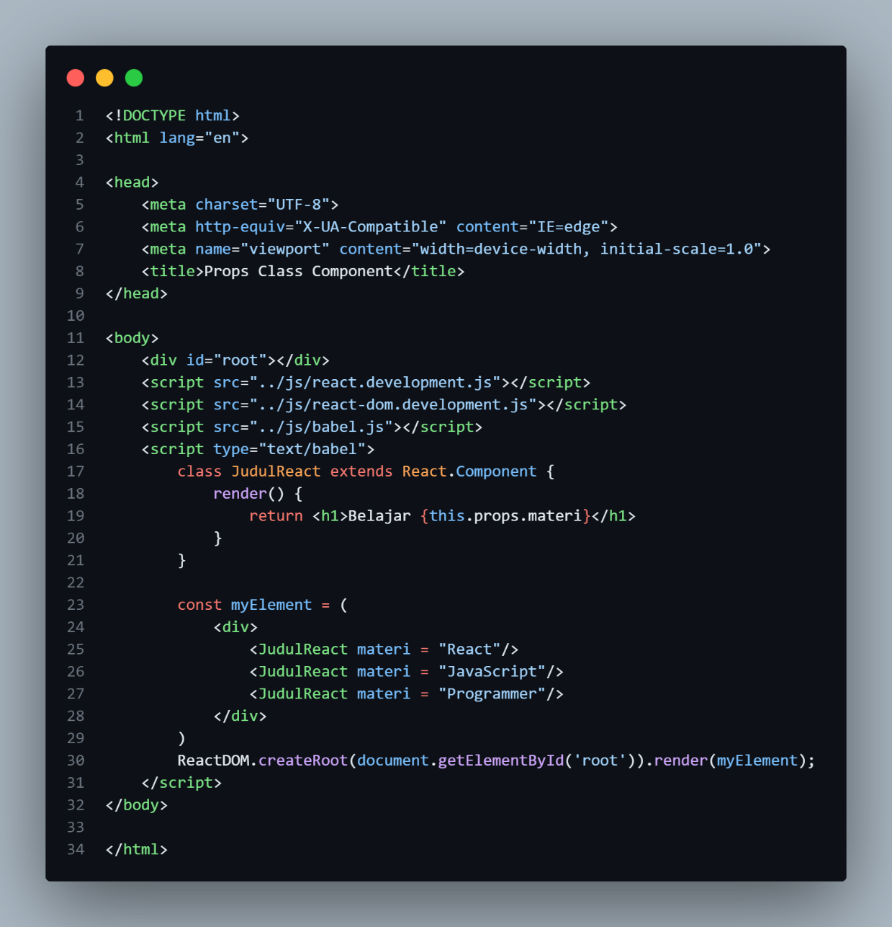

Hasil

1. Props Class Component Percobaan 4

Code

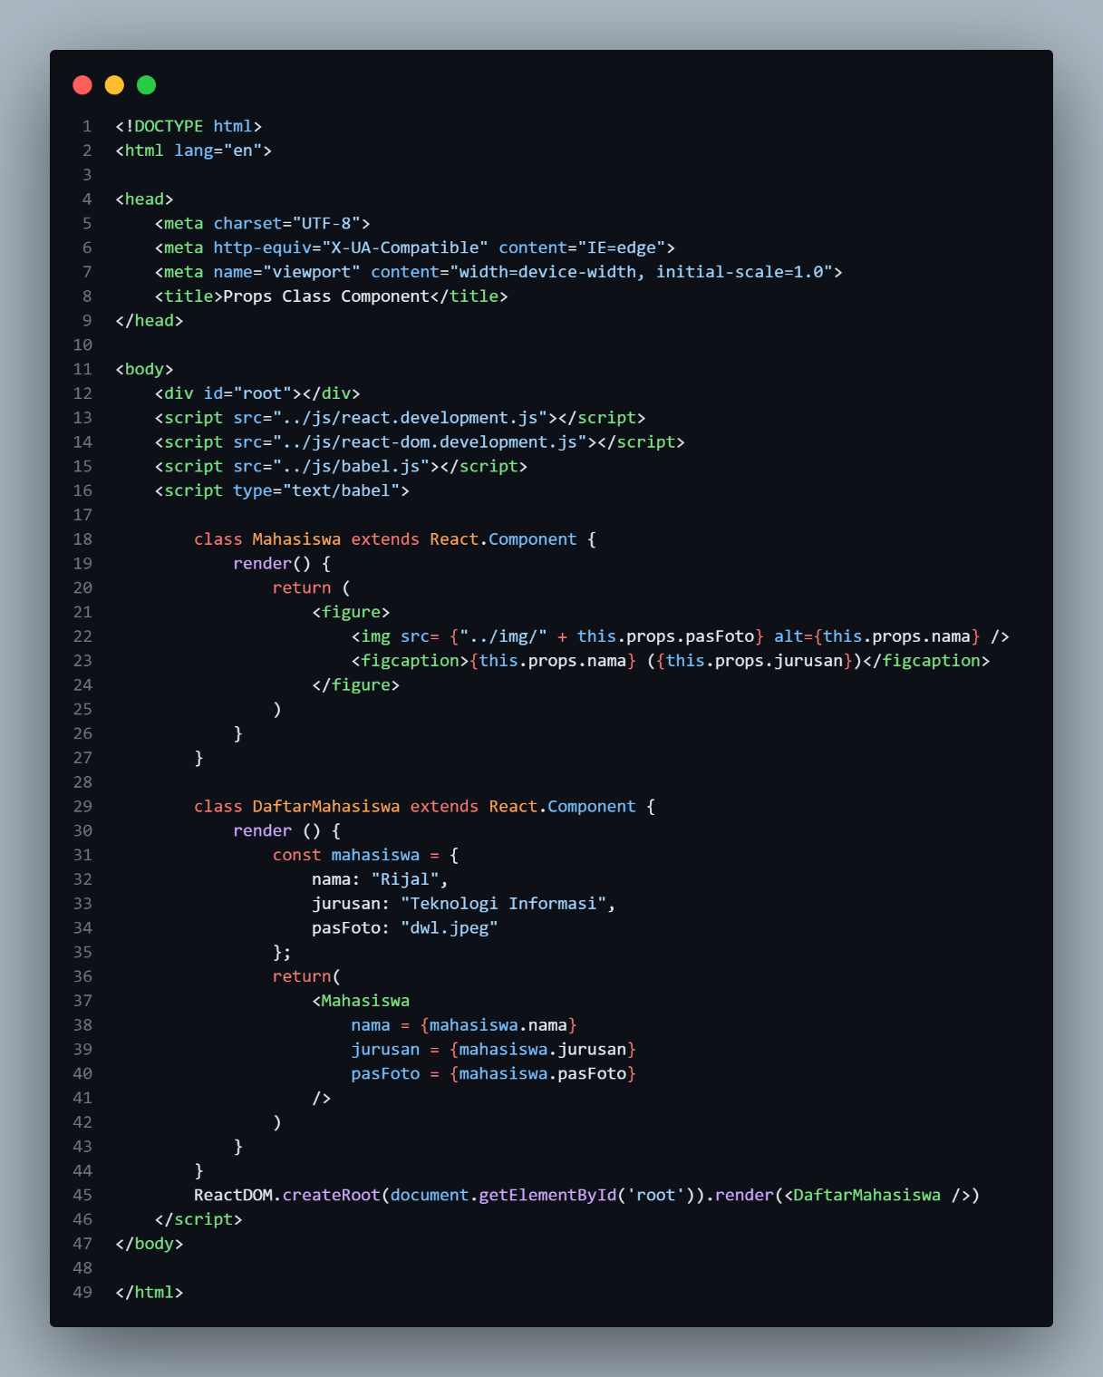

Hasil

1. Children Props Percobaan 1

Code:

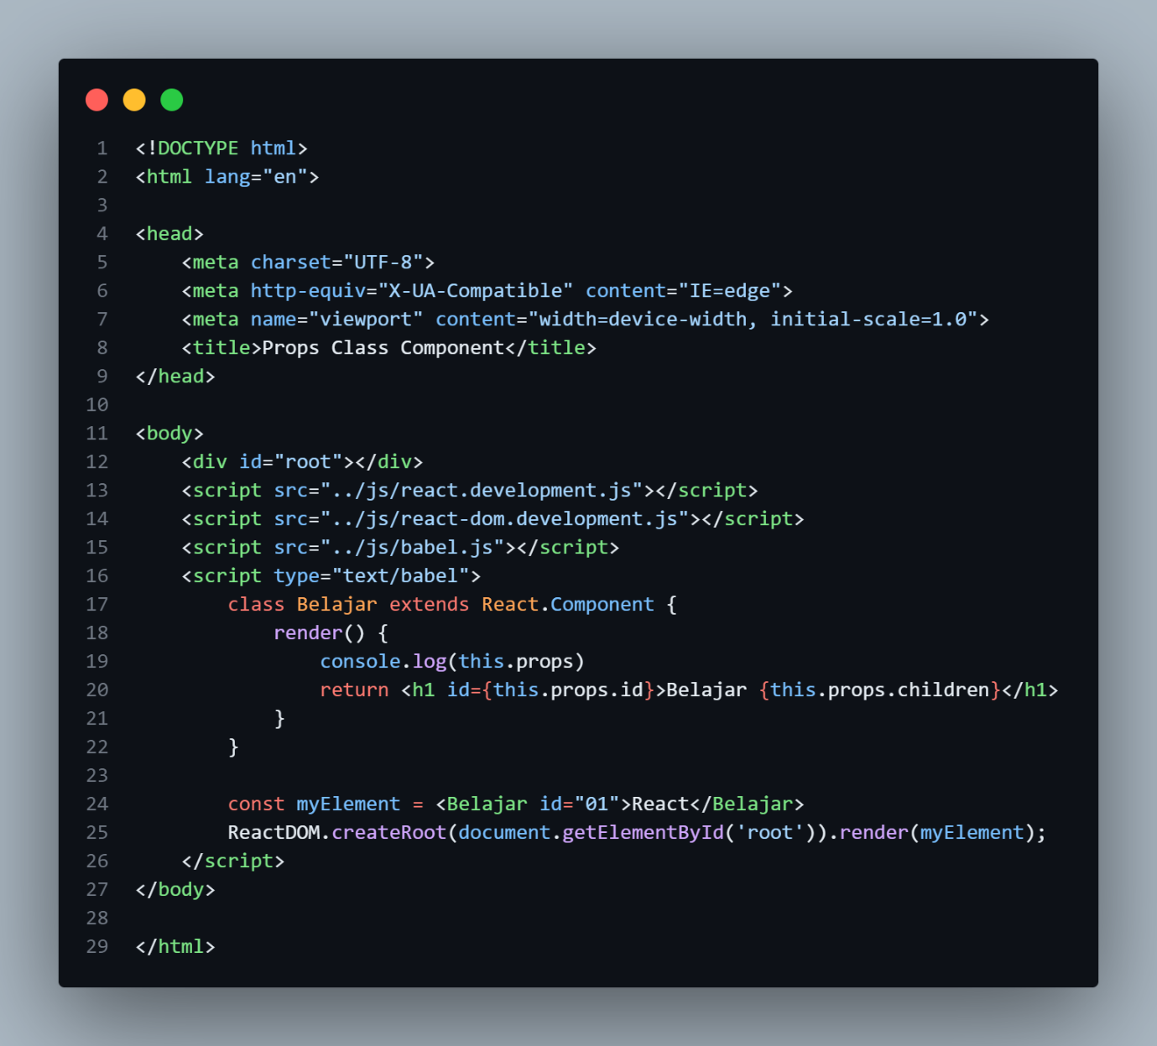

Hasil

1. Props Constructor Percobaan 1

Code:

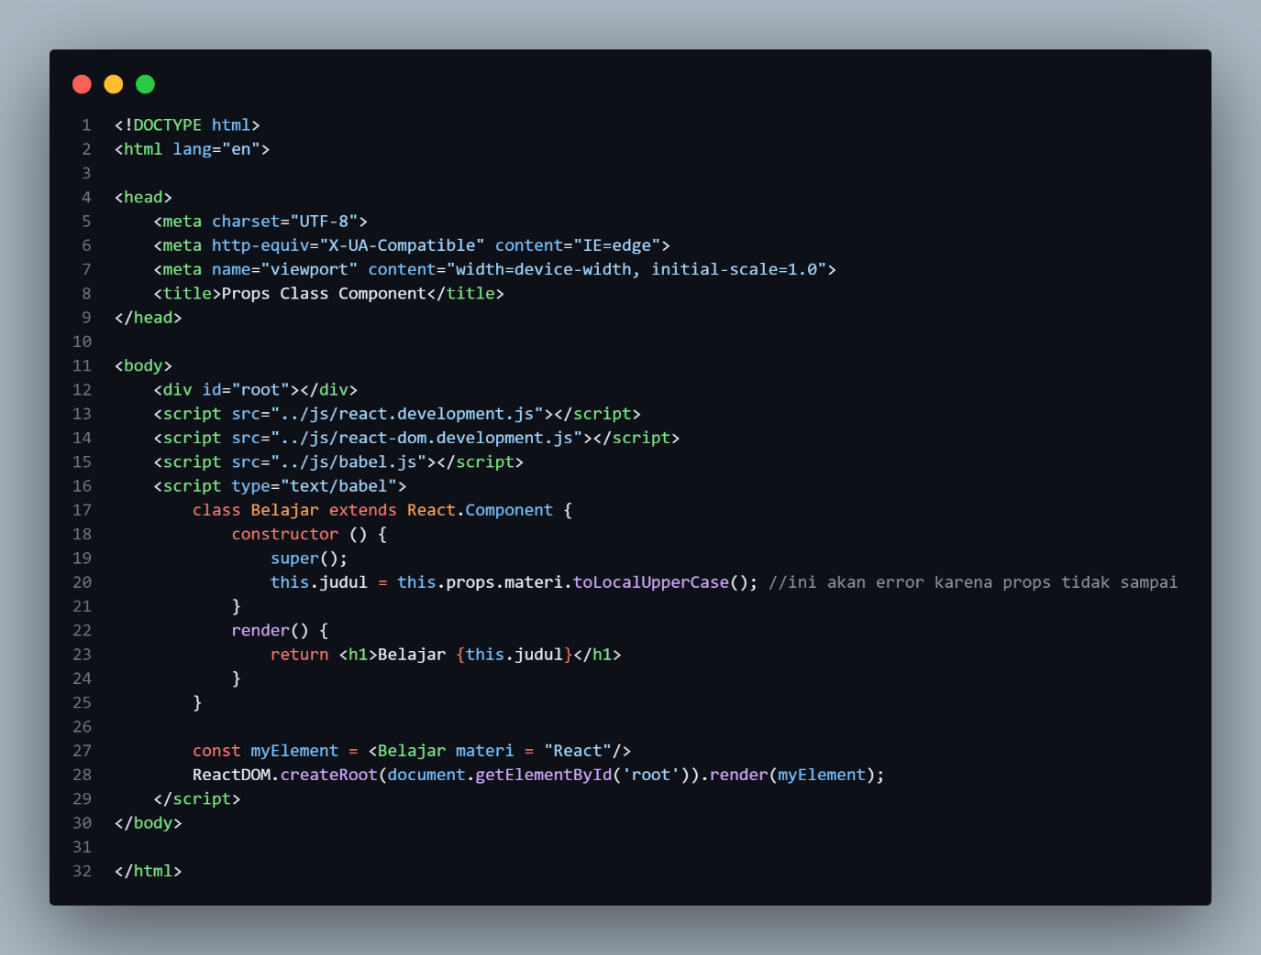

Hasil

Error karena props tidak sampai

1. Props Constructor Percobaan 2

Code:

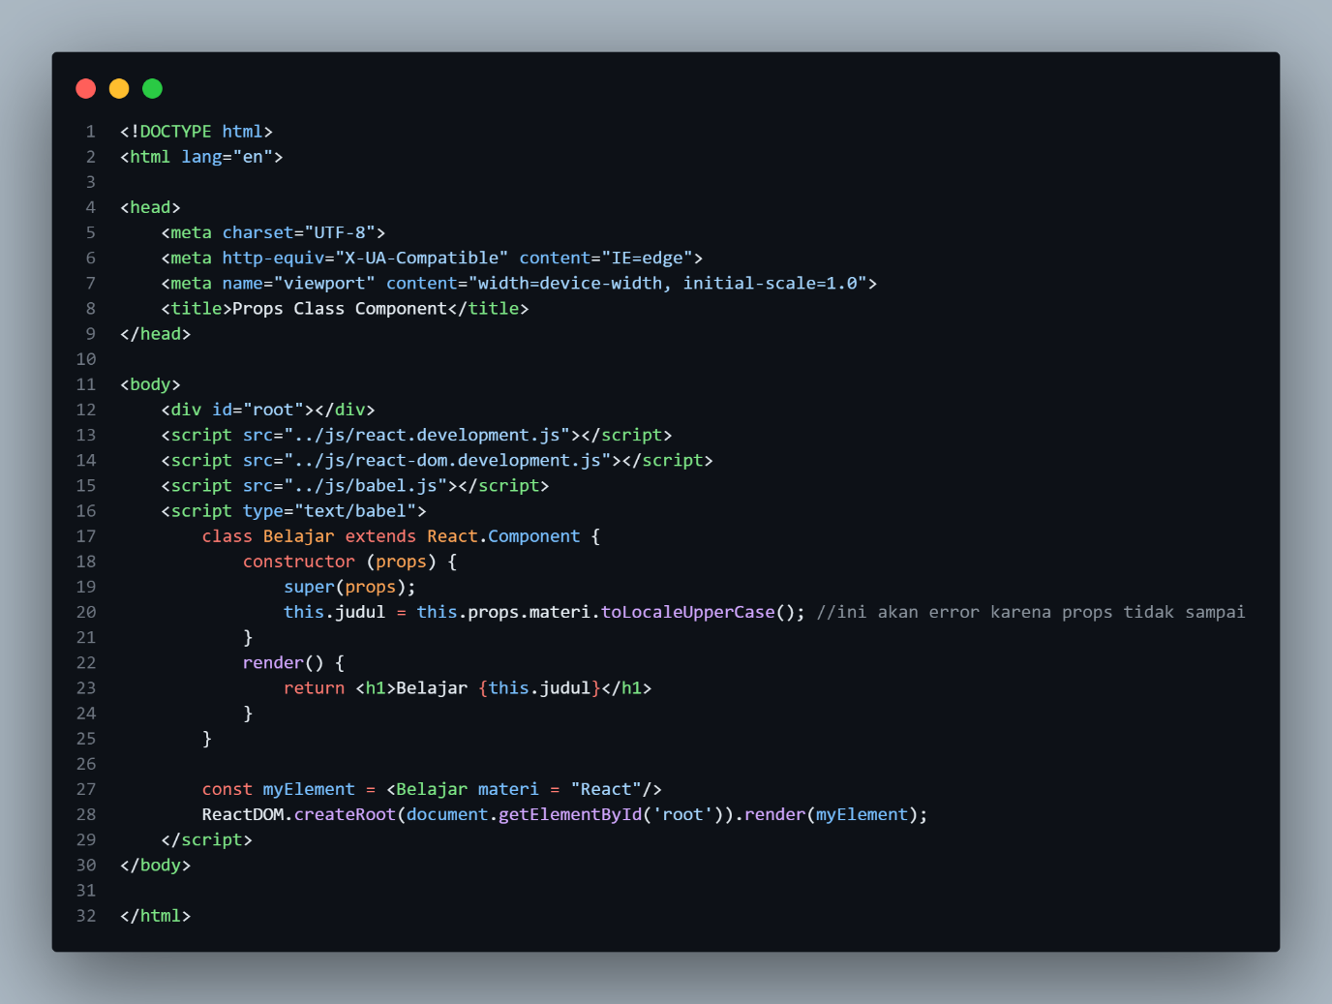

Hasil

1. Props Functional

Code:

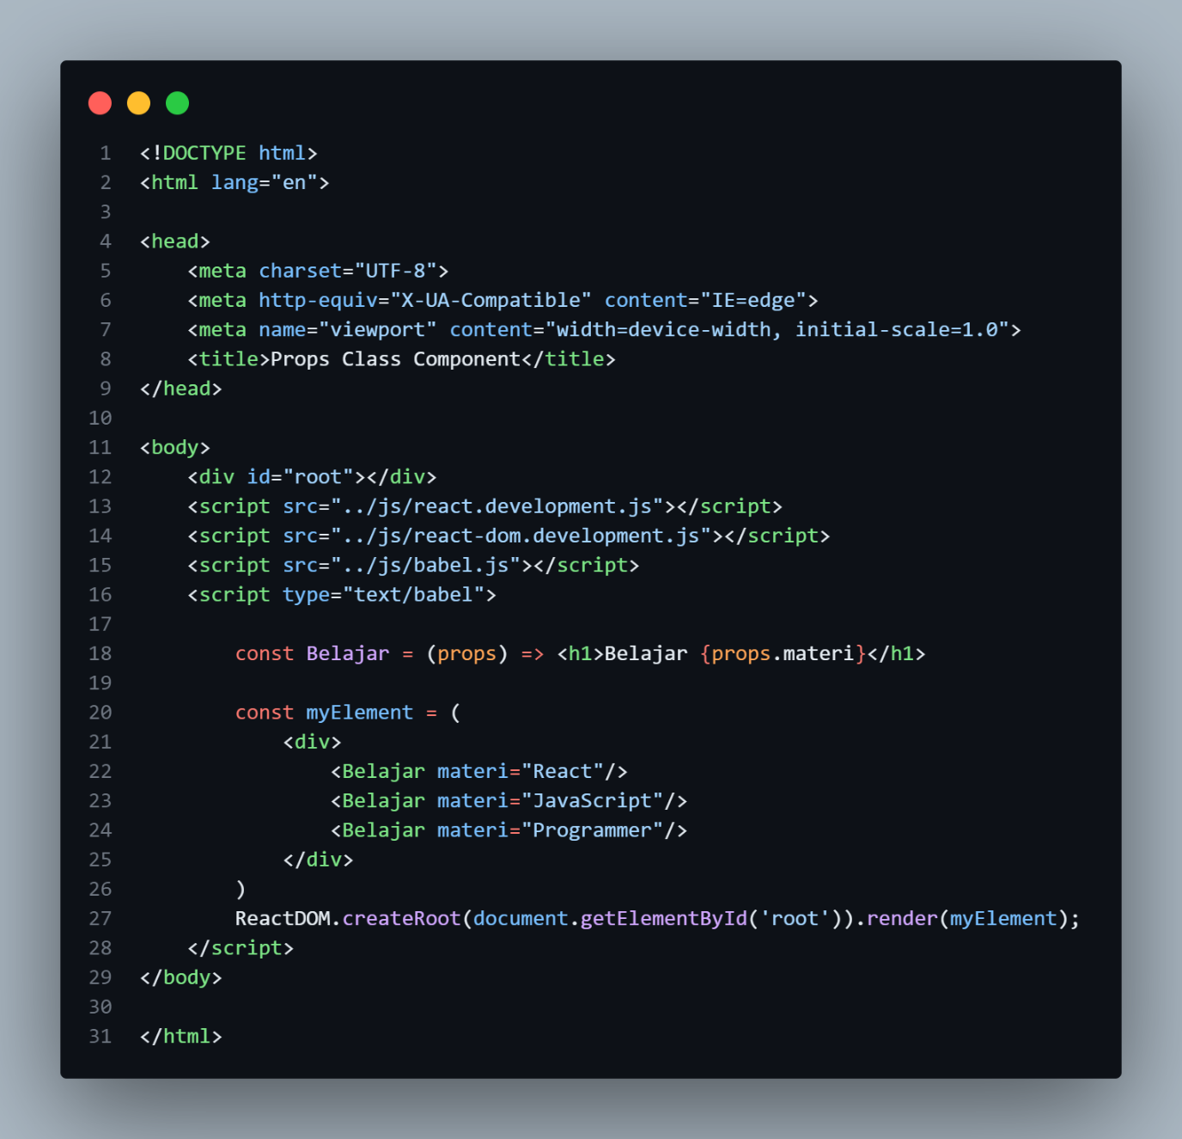

Hasil

1. Tugas 1 PPT

Code:

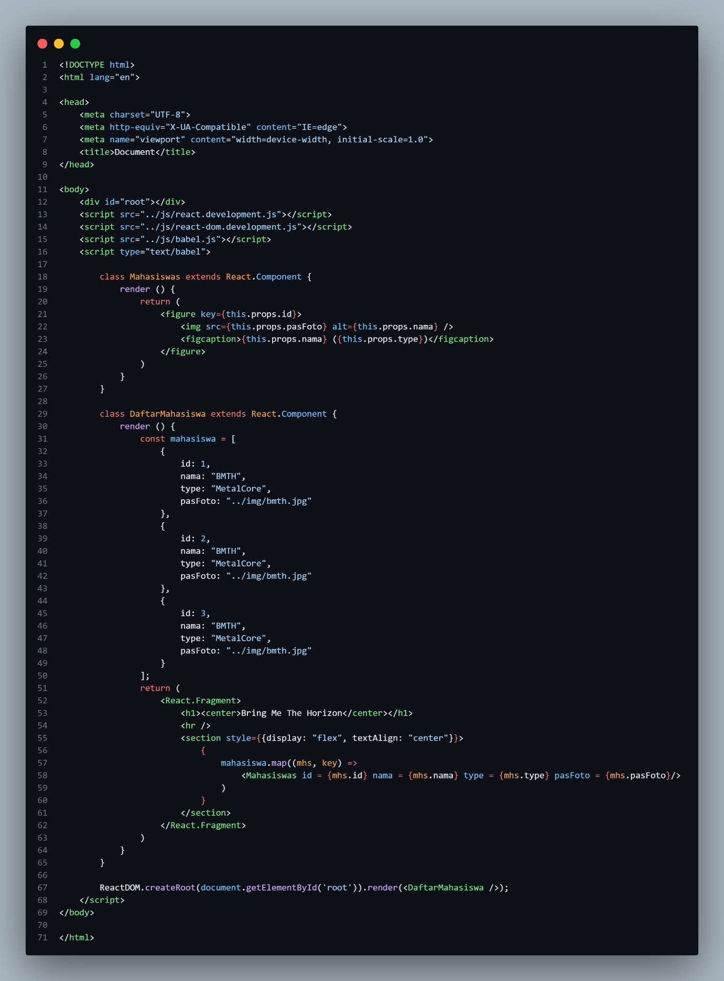

Hasil:

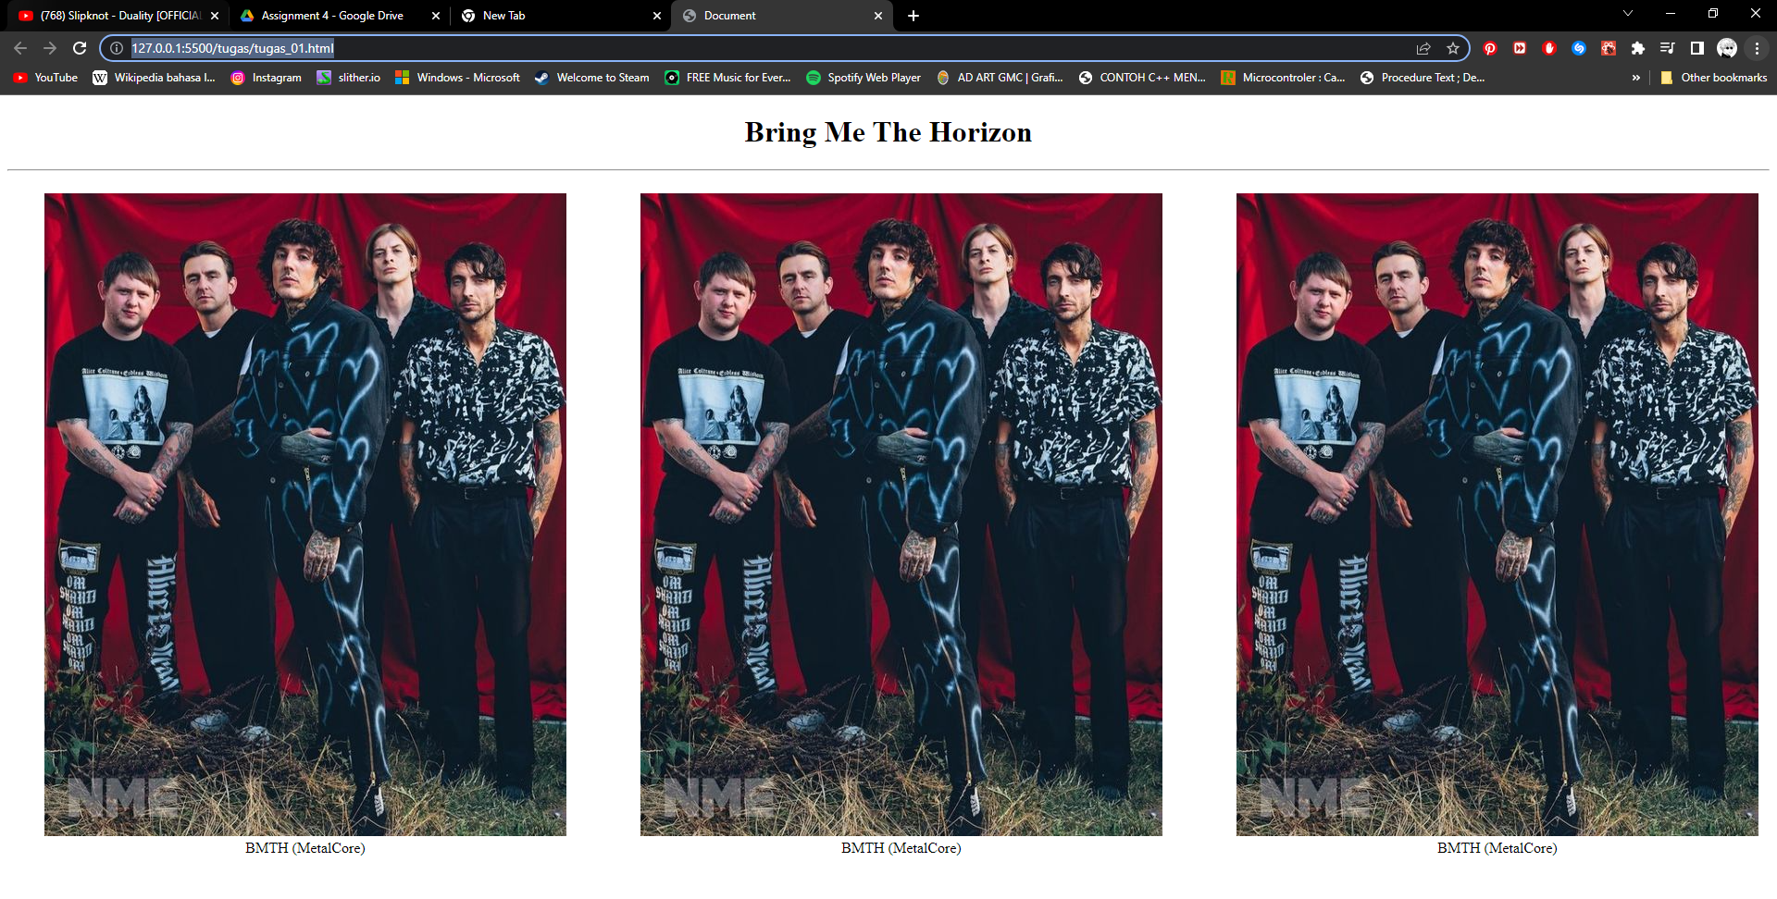

1. Tugas 2 PPT

Code:

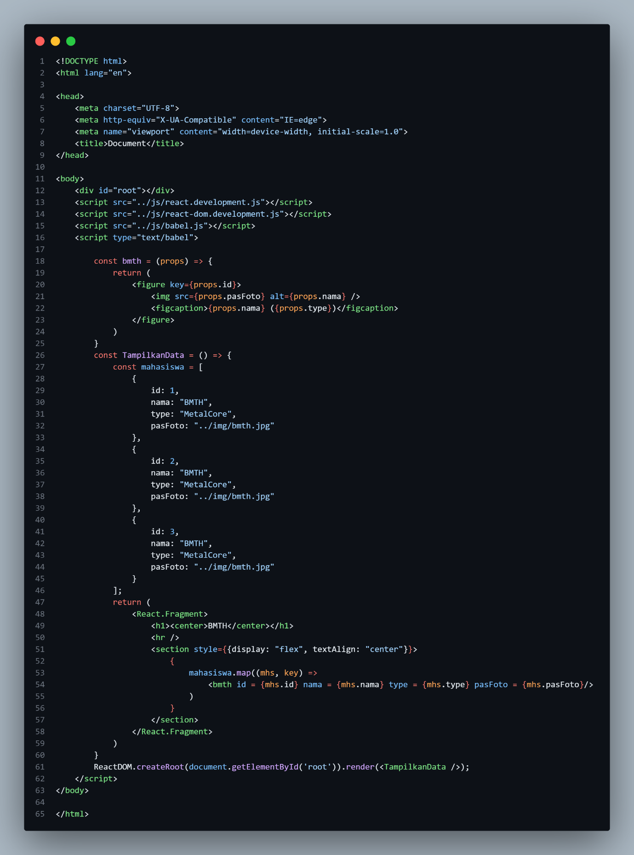

Hasil:

